Registered Office: 46 Margaret Street, GREENOCK, Renfrewshire, Scotland. PA16 8EB

Tel.: 01475 723 847 www.saee.org.uk

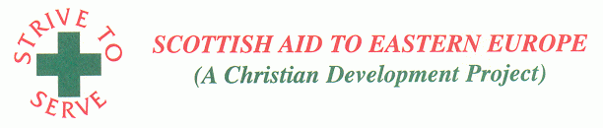

Recognised by HM Revenue and Customs as a charity: Scottish Charity Number SC032485

Please help us to help others

We support Emanuel Hospice in Oradea, Romania every year

We provide: * Nightwear * Incontinence Pads * Nappies

* Toiletries * Arts & Craft Items * Toys

